Chapter 7 Single-Dimensional Arrays
1. See the section "Array Basics."
2. The memory is allocated when an array is created.
3.
x is 60
The size of numbers is 30

4. Indicate true or false for the following statements:
1. Every element in an array has the same type.
Answer: True

2. The array size is fixed after it is declared.
Answer: False

3. The array size is fixed after it is created.
Answer: True

4. The element in the array must be of primitive data type.
Answer: False

5. Which of the following statements are valid array declarations?

int i = new int(30);
Answer: Invalid

double d[] = new double[30];
Answer: Valid

char[] r = new char(1..30);
Answer: Invalid

int i[] = (3, 4, 3, 2);
Answer: Invalid

float f[] = {2.3, 4.5, 5.6};
Answer: Valid

char[] c = new char();
Answer: Invalid
6. You access an array using its index. arrayRefVar[index] is known as an array indexed variable.
7. The array index type is int and its lowest index is 0.
a[2]
8.
(a) double[] list = new double[10];
(b) list[list.length – 1] = 5.5;
(c) System.out.println(list[0] + list[1]);
(d) double sum = 0;
for (int i = 0; i < list.length; i++)
sum += list[i];
(e)
double min = list[0];
for (int i = 1; i < list.length; i++)
if (min > list[i]) min = list[i];
(f)
System.out.println(list[(int)(Math.random() * list.length)]);
(g)
double[] list = {3.5, 5.5, 4.52, 5.6};
9. A runtime exception ArrayIndexOutOfBounds occurs.
10. Line 3: the array declaration is wrong. It should be double[]. The array needs to be created before its been used. e.g. new double[10]
Line 5: The semicolon (;) at the end of the for loop heading should be removed.
Line 5: r.length() should be r.length.
Line 6: random should be random()
Line 6: r(i) should be r[i].
11. 1 1 1 1 1 1
12. No. You may the same card more than once.
13. System.arraycopy(source, 0, t, 0, source.length);
14. The second assignment statement myList = new int[20] creates a new array and assigns its reference to myList.

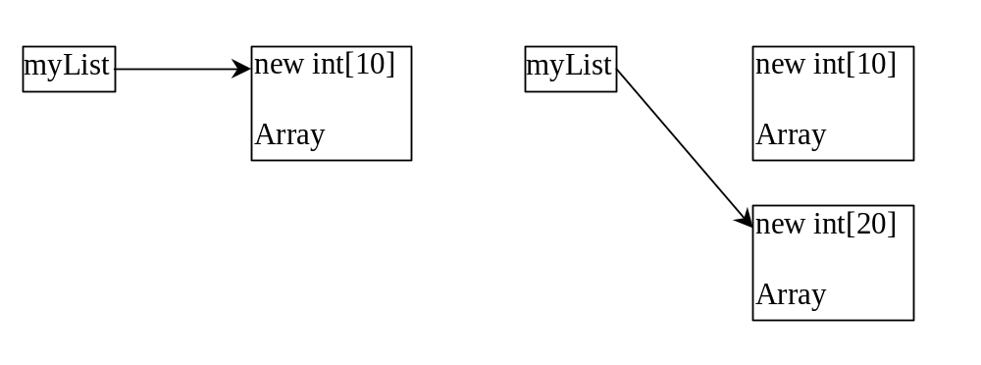

15
It swaps the elements twice. For example, the first element is swapped with the last element once and then the last element is swapped with the first element another time. In effect, the elements are not swapped. Here is the fix:
int[] list = {1, 2, 3, 5, 4};

for (int i = 0, j = list.length - 1; i < list.length / 2; i++, j--) {
// Swap list[i] with list[j]
int temp = list[i];
list[i] = list[j];
list[j] = temp;
}

16 False. When an array is passed to a method, the reference value of the array is passed. No new array is created. Both argument and parameter point to the same array.
17
- numbers is 0 and numbers[0] is 3
- 1 2 3 4 5
18.
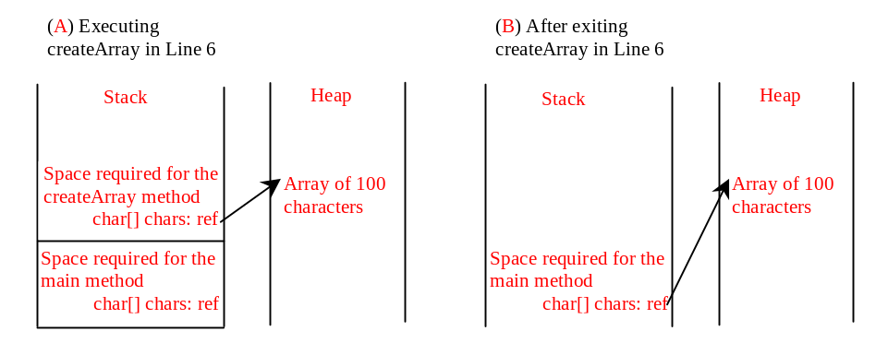
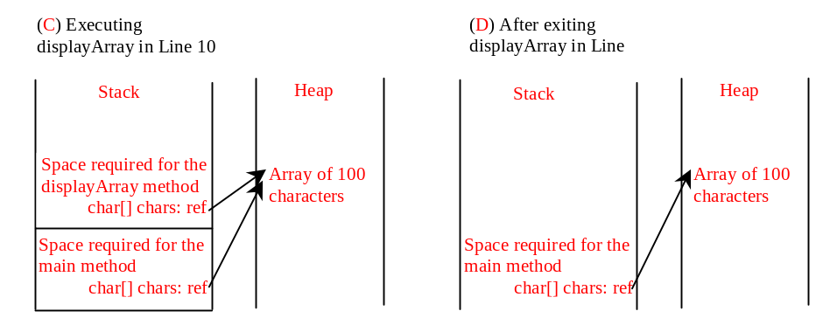
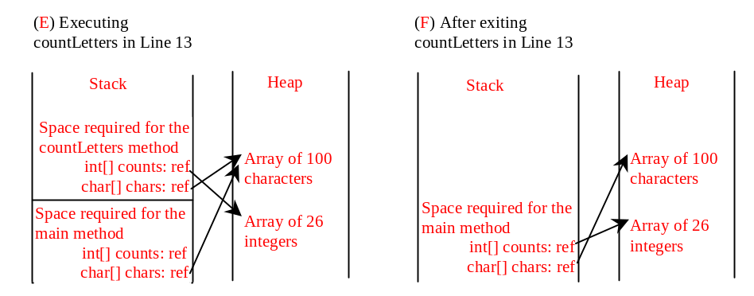
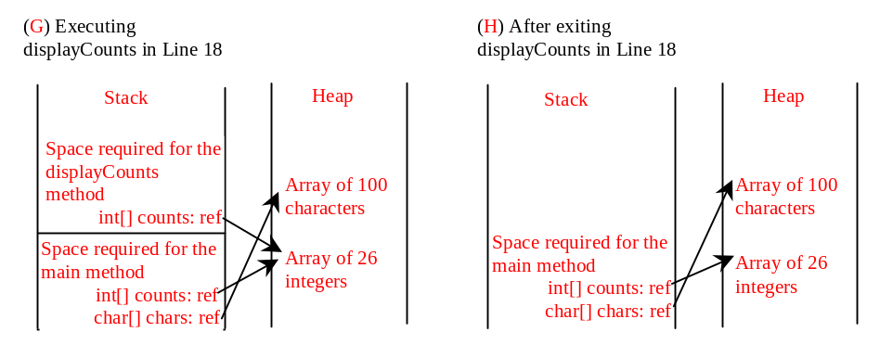
19. Only one variable-length parameter may be specified in a method and this parameter must be the last parameter. The method return type cannot be a variable-length parameter.
20. The last one
printMax(new int[]{1, 2, 3});
is incorrect, because the array must of the double[] type.
21. Replace (low + high) / 2 with (-low + high) / 2 + low
22. Omitted
23. The key should be inserted at –(-4 + 1) = 3.
24. Omitted
25. Omitted
- You can sort an array of any primitive types except boolean. The sort method is void, so it does not return a new array.
27. To apply java.util.Arrays.binarySearch(array, key), the array must be sorted in increasing order.
28.
[7, 7, 7, 7]
[2, 4, 7, 10]
False
29.
public static void main(String[] args)
can be replaced by
public static void main(String args[])

public static void main(String[] x)

public static void main(String x[])

but not

static void main(String x[])

because it is not public.
30.
(1)
Number of strings is 4
I
have
a
dream

(2)
Number of strings is 1
1 2 3

(3)
Number of strings is 0

